WANGARATTA WEST PRIMARY SCHOOL 4642

22 October 2015
NEWSLETTER
DATES TO REMEMBER
TOMORROW Prep – 2 Sports Day
Saturday 24th October WestBeat Drumming playing at the Bishops Lodge 12pm –1pm
Tuesday 3rd November Melbourne Cup Day – NO SCHOOL
Thursday 5th November Curriculum Day - Pupil Free Day
Saturday 7th November Melbourne Warehouse Shopping Trip Fundraiser
Monday 14th December Grade 6 Graduation Night

Ready to Learn
It is important that children arrive at school ready for the day ahead. Research tells us that children need to have full and healthy breakfast so that they achieve their best learning outcomes in the morning.

It is also important that the children arrive at school calm and settled for the day ahead. Without a full tummy and a calm and settled outlook, children will not be ready to learn when they arrive. This makes the job of our staff very challenging when the children arrive not ready to learn.

Student Behaviour
We expect our students at Wangaratta West to actively participate in their learning by arriving to class on time and following teacher’s instructions. I have withdrawn students from class and/or suspended them as they are not following teacher’s instructions. It is an expectation that we work together to ensure the best outcomes for our students.

West Beat Drumming Group
Our West Beat Drumming Group will be performing at the Bishops Lodge this Saturday 24th October from 12pm – 1pm in conjunction with the Chaplaincy Garden Walk project.

Prep - 2 Sports Day
Just a reminer that tomorrow is the grades Prep, One and Two students’ Sports Day here at the school on the Oval between 9:30am and 1:30pm. Like last year, children will rotate around to 10 different activities and Athletic events, as well as some novelty events. We will also enjoy a picnic lunch together with families who are able to stay. Children will be in mixed groups with children of the same grade level from different classes. Each of the ten groups will be allocated a colour to wear on the day to enable parents to find their children easily. If you don’t have that colour, please don’t panic. Try and borrow from another family, we don’t expect you to buy a shirt. Parents are most certainly welcome and encouraged to come along and watch their children participate. We would love to see lots of parents, even if you can only pop in for a little while. Please remember to send your child to school in appropriate footwear and selected coloured top.

School Production DVD
If you have ordered a copy/ies of the School Production DVD, they are now available for collection at the office.

Art Calendars
A reminder that orders and money for the Art Calendars (great gift idea for Christmas) are due back to the office by the end of school tomorrow. NO late orders will be taken.

Warm regards,
Kristy & Craig

Principal: Craig Johnson
Phillipson Street, Wangaratta, Phone 5721.3491
Website: www.wangwestps.vic.edu.au
Email: wangaratta.west.ps@edumail.vic.gov.au
TEXT ABSENCES to 0477.343.814

From the Chaplain’s Desk
- Community Playgroup ~ The story (and craft activity) at Community Playgroup yesterday was Rod Campbell’s “Dear Zoo”. Playgroup operates each Wednesday from 10am to 11.30am and children (birth to school age) are most welcome along with the families. No enrolment forms or cost are involved – just arrive on the day and have fun with us.
- Bringing Up Great Kids Parenting Program ~ Today saw the Reconnector Session with parents sharing how they have implemented strategies and activities introduced during the program..
- Seasons For Growth Reconnector ~ This will be conducted with participants in the program mid-term.
- Extra Transition to Wangaratta High School ~ The first of these sessions was conducted yesterday with another session to be undertaken on Wednesday, November 11th .
- Family & School Working Together – Wangaratta West Primary School & The Centre Initiative ~ Thanks to the parents (and grandparents) who attended the meeting today and training in this great shared venture is soon to commence.
- Thought for the week ~ Look for the good in others and that is what you will find ~ Julie Davey.

Have a great weekend and if you are a gardener, perhaps you might like to pop into one of the gardens in this week’s Chaplaincy Garden Walk. They can be found at 190 Stamps Lane, The Bishop’s Lodge, Ovens Street, 10 Sisely Avenue and 7 Swan Street.

Kindest regards to all,
Rose
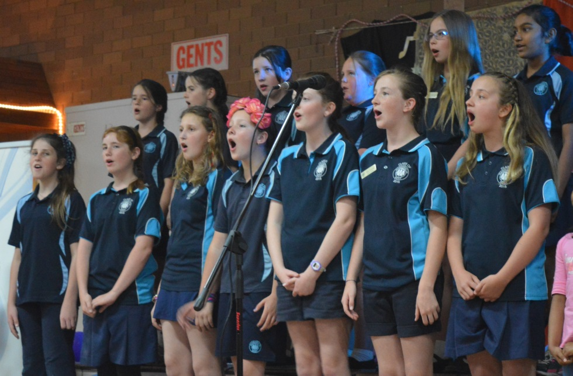

Italian Senior Choir impress yet again!
The Senior Choir were invited to perform at the North East Multicultural Association 10 year anniversary dinner last Saturday night. It was held at Da Vinci Social Club in Wangaratta and was attended by over 80 people. They sung 3 Italian songs and the Australian National Anthem. The students sung beautifully and entertained brilliantly - Piper and Ruby decided to do an impromptu dance around the function room that bought a lot of enthusiasm to the audience!

After their standing ovation from the audience, the children were presented with a certificate of appreciation and a book for the school library which I’m sure all students will enjoy looking at! (Ripley’s Believe It Or Not – has some pretty interesting stories!). Our students represented our school well and we should be very proud.

I’d like to take this opportunity to thank all the choir students who participated and practised in their recess times. Also to Georgina Wills who helped me get the Italian choir up and running in the first place. And lastly to the parents who took time out from their Saturday nights to bring their child to the performance because as we know, without you, the performance would not go ahead so MANY thanks to you. Salute, Tanya Cardamone.

Italian Piper for having great self confidence with Italian and taking part in all Italian
opportunities that have come your way!

0A Isla for the fantastic writing she has been doing and aways having a really good go at
spelling unknown words.

0B Harrison for great reading and acting in guided reding time.
Gemma for well thought out writing for Mrs Anderson & Fred.

0C Kaitlyn for being such a clever reader when reading library books.

1/2A Shyane for her lovely manners and her ability to stay on task.
Osten for the great effort he is putting into our Maths tasks.

3/4A Andrew for consistently completing his reading and spelling homework.
Charlotte for being a cheerful, hard working grade member.
Siara for being a caring, positive, and mischievous asset to our grade.

3/4C Tahlia for being a very organised student and having a great sense of humour.
Naomi for sharing a great reading comprehension strategy with the class.
Teagan for spending her weekend working on a bike safety powerpoint.
Zoe for being a kind and considerate girl ALL YEAR!
Aaron for making strong choices in the classroom and reaching his sticker target!

3/4D Clare for working incredibly hard at home on her English and Maths.
Abbey for being a leader in 3/4D.

5/6A Maddy for her intriguing and beautifully written orientation in her imaginative fiction!
Sethni for her intriguing and beautifully written orientation in her imaginative fiction!

5/6B Piper for all the hard work, time and effort that was put in to organisation the classroom for this
terms Quest.
Sarah for all the hard work, time and effort that was put in to organisation the classroom for this
terms Quest.
Ruby for all the hard work, time and effort that was put in to organisation the classroom for this
terms Quest.
Grace for all the hard work, time and effort that was put in to organisation the classroom for this
terms Quest.

The Rovers United Bruck Cricket Club - Milo In2Cricket & T.20 Blast Cricket Programs will start on Friday, 23rd October, 2015 at 5.15 pm at the W J Findlay Oval, Wangaratta and we would love to see as many boys & girls
register online at – www.playcricket.com.au & register under Rovers United Bruck CC.

The MILO in2CRICKET program is designed for boys and girls from 5 to 8 years old. It is a fast, fun and active program that emphasises maximum participation, basic motor and cricket skill development. It is experience
based and builds its foundations on the essentials for lifelong involvement in physical activity and sport.

The MILO T20 Blast program is a super fun, social, safe, cricket program for boys and girls from 9 to 10 years old. The program is much shorter than traditional cricket, with a maximum of 90 minutes playing time. All the equipment is supplied and the games take place at the same venue each week, at a local cricket club or community
centre

WANGARATTA WEST PRIMARY SCHOOL ~ FUNDRAISER
MELBOURNE SHOPPING TOUR!!!
SATURDAY 7th November
Bus leaves school at 5.30am sharp
returning to school by 9pm.

Come alone or bring some friends for a full day of shopping (Christmas is not far away), laughs and prizes to be won on the bus.

12 Warehouse’s that are not open to the public will be visited with an experience shopping guide who has insided knowledge of great bargains!!!!

Shops include Toyworx, The Linen Factory, Diana Ferrari, Natio, Converse, Newmans/Ernest Hillier Chocolate and shops for kids/mens/women’s clothing and kitchenware.

Book & pay for your seat NOW at the office ~ $50 per person.

